**“Experiment 3.1”**

Student Name: **SUMIT KUMAR** UID: **20BCS8226**

Branch: **CSE** Section/Group: **808-A**

Semester: **5** Date of Submission: **12-11-22**

Subject Name: **Design and Analysis of Algorithms Lab** Subject Code: **20CSP-312**

## **Aim:**

Code and analyze to do a depth-first search (DFS) on an undirected graph. Implementing an application of DFS such as (i) to find the topological sort of a directed acyclic graph, OR (ii) to find a path from source to goal in a maze.

**Program Code:**

## Code and analyze to do a depth-first search (DFS) on an undirected graph

#include <bits/stdc++.h> using namespace std;

class Graph{ public:

map<int, bool> visited; map<int, list<int> > adj; void addEdge(int v, int w);

void DFS(int v);

};

void Graph::addEdge(int v, int w) {

adj[v].push_back(w);

}

void Graph::DFS(int v)

{

visited[v] = true; cout << v << " ";

list<int>::iterator i;

for (i = adj[v].begin(); i != adj[v].end(); ++i) if (!visited[*i])

DFS(*i);

}

int main()

{

Graph g; g.addEdge(0, 1);

g.addEdge(0, 2);

g.addEdge(1, 2);

g.addEdge(2, 0);

g.addEdge(2, 3);

g.addEdge(3, 3);

cout << "Following is Depth First Traversal" " (starting from vertex 2) \n";

g.DFS(2);

return 0;

}

# Output:

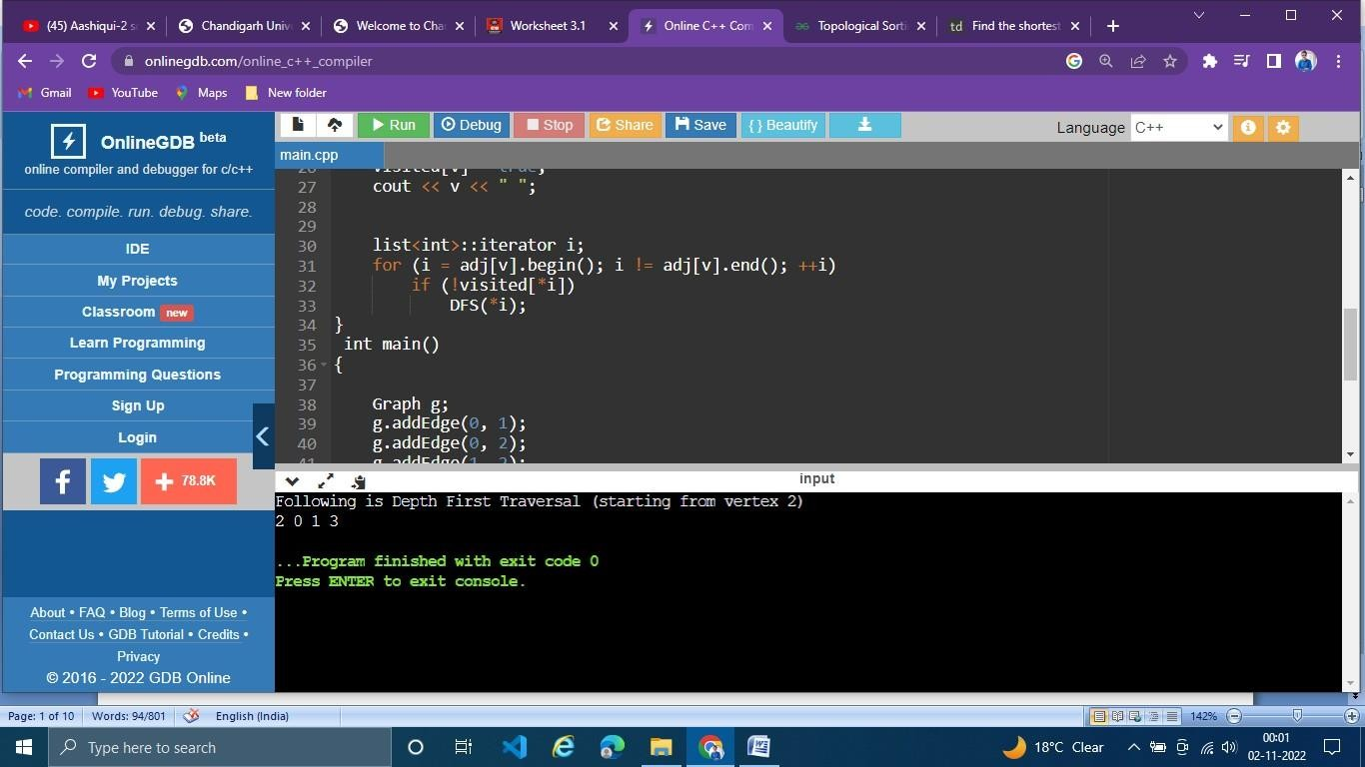

## to find the topological sort of a directed acyclic graph

**Program Code:**

#include <bits/stdc++.h> using namespace std;

class Graph { int V;

list<int>* adj;

void topologicalSortUtil(int v, bool visited[],

stack<int>& Stack);

public:

Graph(int V);

void addEdge(int v, int w); void topologicalSort();

};

Graph::Graph(int V)

{

this->V = V;

adj = new list<int>[V];

}

void Graph::addEdge(int v, int w)

{

adj[v].push_back(w);

}

void Graph::topologicalSortUtil(int v, bool visited[], stack<int>& Stack)

{

visited[v] = true;

list<int>::iterator i;

for (i = adj[v].begin(); i != adj[v].end(); ++i) if (!visited[*i])

topologicalSortUtil(*i, visited, Stack);

Stack.push(v);

}

void Graph::topologicalSort()

{

stack<int> Stack;

bool* visited = new bool[V]; for (int i = 0; i < V; i++)

visited[i] = false;

for (int i = 0; i < V; i++) if (visited[i] == false)

topologicalSortUtil(i, visited, Stack); while (Stack.empty() == false) {

cout << Stack.top() << " "; Stack.pop();

}

}

int main()

{

Graph g(6);

g.addEdge(5, 2);

g.addEdge(5, 0);

g.addEdge(4, 0);

g.addEdge(4, 1);

g.addEdge(2, 3);

g.addEdge(3, 1);

cout << "Following is a Topological Sort of the given " "graph \n";

g.topologicalSort();

return 0;

}

# Output:

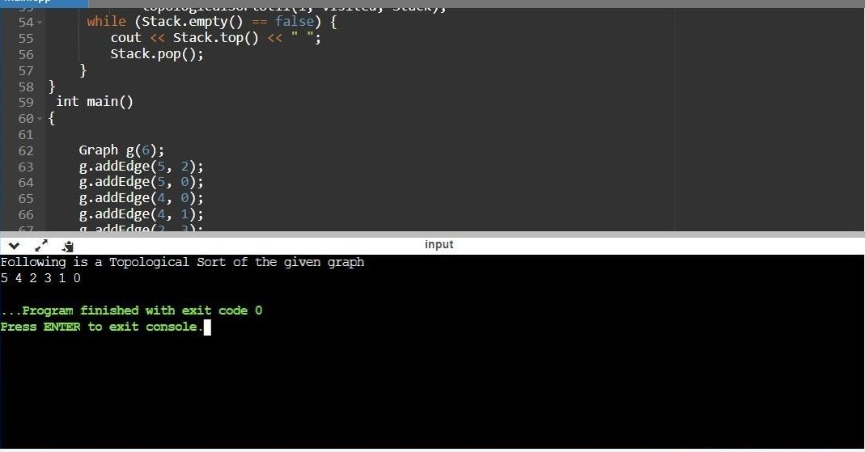

1. **to find a path from source to goal in a maze.**

# Program Code :-

#include <iostream>

#include <vector> #include <climits> #include <cstring> using namespace std;

bool isSafe(vector<vector<int>> &mat, vector<vector<bool>> &visited, int x, int y)

{

return (x >= 0 && x < mat.size() && y >= 0 && y < mat[0].size()) && mat[x][y] == 1 && !visited[x][y];

}

void findShortestPath(vector<vector<int>> &mat, vector<vector<bool>> &visited, int i, int j, int x, int y, int &min_dist, int dist)

{

if (i == x && j == y)

{

min_dist = min(dist, min_dist); return;

}

visited[i][j] = true;

if (isSafe(mat, visited, i + 1, j)) {

findShortestPath(mat, visited, i + 1, j, x, y, min_dist, dist + 1);

}

if (isSafe(mat, visited, i, j + 1)) {

findShortestPath(mat, visited, i, j + 1, x, y, min_dist, dist + 1);

}

if (isSafe(mat, visited, i - 1, j)) {

findShortestPath(mat, visited, i - 1, j, x, y, min_dist, dist + 1);

}

if (isSafe(mat, visited, i, j - 1)) {

findShortestPath(mat, visited, i, j - 1, x, y, min_dist, dist + 1);

}

visited[i][j] = false;

}

int findShortestPathLength(vector<vector<int>> &mat, pair<int, int> &src, pair<int, int> &dest)

{

if (mat.size() == 0 || mat[src.first][src.second] == 0 || mat[dest.first][dest.second] == 0) {

return -1;

}

int M = mat.size(); int N = mat[0].size();

vector<vector<bool>> visited; visited.resize(M, vector<bool>(N)); int min_dist = INT_MAX;

findShortestPath(mat, visited, src.first, src.second, dest.first, dest.second,

min_dist, 0);

if (min_dist != INT_MAX) { return min_dist;

}

return -1;

}

int main()

{

vector<vector<int>> mat =

{

{ 1, 1, 1, 1, 1, 0, 0, 1, 1, 1 },

{ 0, 1, 1, 1, 1, 1, 0, 1, 0, 1 },

{ 0, 0, 1, 0, 1, 1, 1, 0, 0, 1 },

{ 1, 0, 1, 1, 1, 0, 1, 1, 0, 1 },

{ 0, 0, 0, 1, 0, 0, 0, 1, 0, 1 },

{ 1, 0, 1, 1, 1, 0, 0, 1, 1, 0 },

{ 0, 0, 0, 0, 1, 0, 0, 1, 0, 1 },

{ 0, 1, 1, 1, 1, 1, 1, 1, 0, 0 },

{ 1, 1, 1, 1, 1, 0, 0, 1, 1, 1 },

{ 0, 0, 1, 0, 0, 1, 1, 0, 0, 1 },

};

pair<int, int> src = make_pair(0, 0); pair<int, int> dest = make_pair(7, 5);

int min_dist = findShortestPathLength(mat, src, dest);

if (min_dist != -1)

{

cout << "The shortest path from source to destination " "has length " << min_dist;

}

else {

cout << "Destination cannot be reached from a given source";

}

return 0;

}

**OUTPUT:**

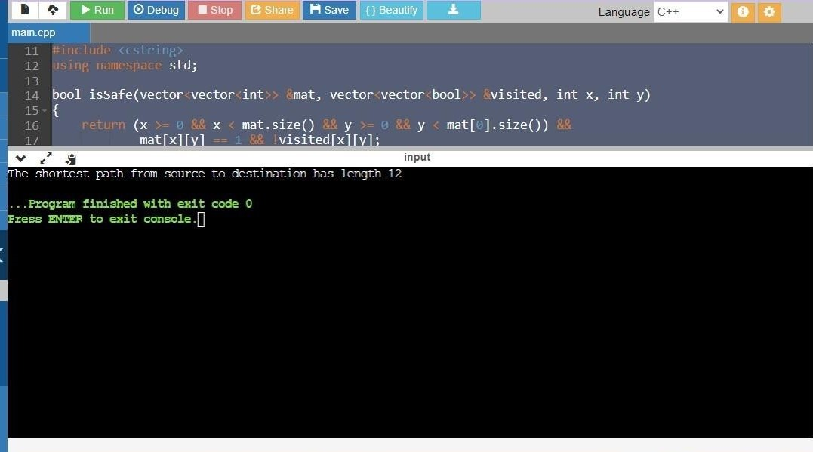

**Learning Outcomes:-**

* 1. Create a program keeping in mind the time complexity
  2. Create a program keeping in mind the space complexity
  3. Steps to make optimal algorithm

**Evaluation Grid (To be created per the faculty's SOP and Assessment guidelines):**

|  |  |  |  |
| --- | --- | --- | --- |
| Sr. No. | Parameters | Marks Obtained | Maximum Marks |
| 1. | Worksheet completion including writing learning objectives/Outcomes.  (To be submitted at the end of the day). |  |  |
| 2. | Post-Lab Quiz Result. |  |  |
| 3. | Student Engagement in  Simulation/Demonstration/Performance and Controls/Pre-Lab Questions. |  |  |
|  | Signature of Faculty (with Date): | Total Marks Obtained: |  |